Patient Intake Form

Name: _________________________________________ Date: ____/____/______
Date of Birth: ____/____/_____ Email: _______________________________
Mailing Address: ____________________________________________________________________________
Phone Number (Home): ________________ Phone Number (Cell): ___________________
Sex: M or F Marital Status: ___________ Occupation: ____________________
If Patient is a minor (under the age of 18):
Guardian’s name: __________________________ Relationship: ____________________

Emergency Contact:
Name: ____________________________ Relationship: ______________________
Phone Number: __________________________

Health Insurance:
Primary Insurance Company: _________________________ Policy Holder Name: __________________
ID Number: ________________________________
Secondary Insurance Company: _______________________ Policy Holder Name: __________________
ID Number: ________________________________

Referring Physician:
Name: ______________________________ Office Name: ___________________________

Primary Care Physician:
Name: ______________________________ Office Name: ___________________________

Other:
Are you currently seeing someone else for any kind of therapy? Y or N
If Yes, where/what kind? _____________________________________________________________________

How did you hear about Dynamic PTSC? _________________________________________________________
What is your preferred method of contact? ______________________________________________________
Are we allowed to leave a voicemail on your cell? _________ at your home number? ________

Injury Information:
What body part are we seeing you for? __________________________________________________________
Onset of symptoms or date of injury: ___________________________________________________________
What tests have been completed for this injury? XRAY MRI CT Scan Other ___________________ None
What best describes your pain? Achy Sharp Burning Stabbing Tingling Other _______________________
On a scale of 0-10 (0= no pain and 10= worst pain imaginable) my pain at best is ______ and at worst is _____.
Please mark where you have symptoms of the following image:

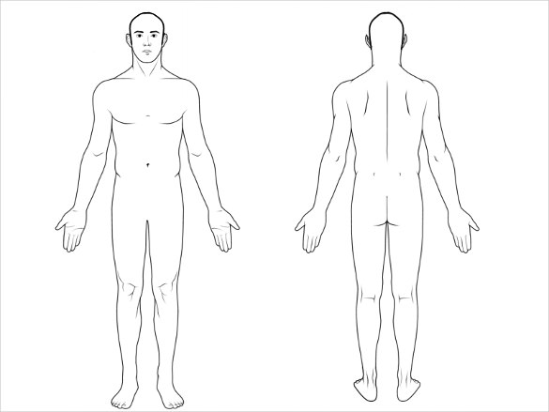

Are you currently taking any medications or supplements for your symptoms? Y or N
If Yes, what are you taking? ___________________________________________________________________
__________________________________________________________________________________________

What are your goals for physical therapy? _______________________________________________________
__________________________________________________________________________________________

Medical History:
I have a history of (please circle all that apply):
High Blood Pressure Recent weight loss/gain
Heart Disease Lung disease
Diabetes Thyroid condition
Epilepsy Low blood sugar
Hearing loss Cancer
Asthma Impaired vision
Osteoporosis Fractures
Frequent falls Ringing in ears
Shortness of breath Dizziness
Angina (chest pain) Concussion
Arthritis Difficulty swallowing
Stroke Impaired memory
Depression Anxiety

Have you fallen recently? Y or N
Do you have a pacemaker or surgical implant? Y or N
Are you pregnant: Y or N
I have the following allergies: __________________________________________________________________
Please list any serious illnesses, accidents, and/or surgeries: _________________________________________
__________________________________________________________________________________________
__________________________________________________________________________________________
Please list all your medications: ________________________________________________________________
__________________________________________________________________________________________
__________________________________________________________________________________________

Have you been seen by a physical therapist before? Y or N
If yes, what for? ____________________________________________________________________________

How much caffeine do you consume daily? ________________
Do you smoke? Y or N If yes, how long have you been a smoker? _______ cigarettes/day? _____
How many days a week do you drink alcohol? ______

The above is true to the best of my knowledge.

Signature: Date:

Attendance Policy:
Consistent attendance and adherence to the planned treatment regimen is paramount to your care and recovery. We require a 24-hour cancellation notice for all appointments. If notice is not given within 24 hours, you may be charged a $40.00 fee.

Consent for Treatment:
I hereby authorize Dynamic Physical Therapy and Sports Conditioning to evaluate and treat my injury. I understand there is no guarantee that my condition will improve. I further understand that response to physical therapy evaluations and treatments vary from person to person and on rare occasions a treatment session may aggravate symptoms.

Payment Policy:
- Copayments are to be paid in full at the time of service.
- I understand that if I have a deductible, I am to pay an estimated amount of that visit at the time of service.

Emergency Policy:
In the event of a fall, Dynamic Physical Therapy and Sports Conditioning reserves the right to contact emergency services.

Notice of privacy practice:
Dynamic Physical Therapy and Sports Conditioning is committed to protecting our patients’ health information and privacy. In compliance with Federal HIPPA Regulations, therapists and staff will make their best efforts to ensure that your protected health information is kept private at all times. By signing below, I acknowledge that I may request a copy of Dynamic Physical Therapy and Sports Conditioning’s Notice of Privacy Practices.

Authorization To Release Protected Health Information:
I hereby authorize one or all of the designated parties listed below to request and receive the release of any protected health information.

Name:________________________________________ Relationship:______ __________________

Name:___________________________________________ _ _Relationship:_________ _______________

Name:_____________________________________________ _Relationship: ________________________

By signing below, I verify that I have read and agree with the above.

Patient Name:_____________ ______________

Signature:______________________________________________ Date:________________________

